3346 Assignment 2

Zaid Albirawi  
250626065

1. 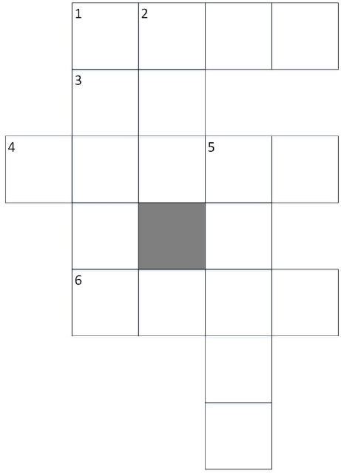Consider the crossword puzzle shown. The available words that can used are  
     
     
     
     
     
     
     
     
     
     
     
     
     
     
     
     
   at, eta, be, hat, he, her, it , him , on, one, desk, dance, usage, easy, dove, first, else, loses, fuels, help ,haste, given, kind, sense, soon, sound, this , think.  
   1. Given the representations with nodes for the positions (1-across, 2-down, etc.) and words for the domains, specify the network after domain consistency and arc consistency have halted.   
        
      Variables: {1-across, 1-down, 2-down, 3-across, 4-across, 5-down, 6-across}  
        
      D1-across = D1-down = D2-down = D3-across = D4-across = D5-down = D6-across = { at, eta, be, hat, he, her, it , him , on, one, desk, dance, usage, easy, dove, first, else, loses, fuels, help ,haste, given, kind, sense, soon, sound, this , think}  
        
      Constraints = { 1-across[0] = 1-down[0]  
       1-across[1] = 2-down[0]  
       1-down[1] = 3-across[0]  
       2-down[1] = 3-across[1]  
       1-down[2] = 4-across[1]  
       2-down[2] = 4-across[2]  
       4-across[3] = 5-down[0]  
       1-down[4] = 6-across[0]  
       5-down[2] = 6-across[2] }.  
        
      After domain consistency  
        
      D1-across = {desk, easy, dove, else, help, kind, soon, this}  
      D1-down = {dance, usage, first, loses, fuels, haste, given, sense, sound, think}  
      D2-down = {eta, hat, her, him, one}  
      D3-across = {at, be, he, it, on}  
      D4-across = {dance, usage, first, loses, fuels, haste, given, sense, sound, think}  
      D5-down = {dance, usage, first, loses, fuels, haste, given, sense, sound, think}  
      D6-across = {desk, easy, dove, else, help, kind, soon, this}  
        
      After arc consistency  
        
      D1-across = {help, soon, this}   
      D1-down = {haste, sound, think}  
      D2-down = {eta, her, one}  
      D3-across = {at, he, on}  
      D4-across = {first, fuels, usage}  
      D5-down = {given, loses, sense}  
      D6-across = {desk, dove, easy, else, kind}  
        
      Domain-consistent constraint network:  
        
      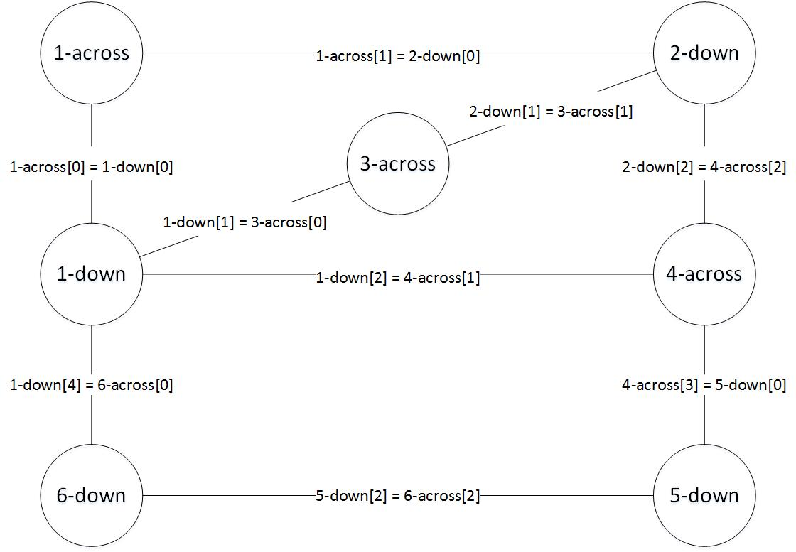
   2. Consider the dual representation, in which the squares on the intersection of words are the variables and their domains are the letters that could go in these positions. Give the domain after this network has made arc consistent. Does the result after arc consistency in this representation correspond to the result in part (a)?  
        
      Variables: {1A1D, 1A2D, 1D3A, 2D3A, 1D4A, 2D4A, 4A5D, 1D6A, 5D6A}  
        
      D1A1D = D1A2D = D1D3A = D2D3A = D1D4A = D2D4A = D4A5D = D1D6A = D5D6A = {a, b, c, d, e, f, g, h, i, k, l, m, n, o, p, r, s, t, u, v, y}  
        
      Constraints = { |1-across| = 4  
       |1-down| = 5  
       |2-down| = 3  
       |3-across| = 2  
       |4-across| = 5  
       |5-down| = 5  
       |6-across| = 4 }.  
        
      After domain consistency  
        
      D1A1D = {d, e, f, h, o, s, t}  
      D1A2D = {a, e, h, i, l, o, s, t, u}  
      D1D3A = {a, e, h, i, l, o, s, t, u}  
      D2D3A = {a, e, h, i, n, o, t}  
      D1D4A = {a, e, i, l, n, o, s, t, u}  
      D2D4A = {a, e, i, n, r, s, v}  
      D4A5D = {d, e, g, i, k, l, o, s, t}  
      D1D6A = {a, d, e, k, s, t}  
      D5D6A = {a, e, i, n, r, s, v}  
        
      After arc consistency   
        
      D1A1D = {h, s, t}  
      D1A2D = {e, h, o}  
      D1D3A = {a, h, o}  
      D2D3A = {e, n, t}  
      D1D4A = {s, i, u}  
      D2D4A = {a, e, r}  
      D4A5D = {g, l, s}  
      D1D6A = {d, e, k}  
      D5D6A = {v, n, s}  
        
      The results is consistent with the one from part a.
   3. Show how the variable elimination can be used to solve the crossword problem. Start from the arc-consistency network from part (a)?  
        
      Start by eliminating 1D

|  |  |  |  |  |
| --- | --- | --- | --- | --- |
| 1D | 1A | 3A | 4A | 6A |
| haste | help | at | Usage | Easy |
| haste | help | at | Usage | else |
| sound | soon | on | fuels | desk |
| sound | soon | on | fuels | dove |
| think | this | he | first | kind |

Eliminate 4A

|  |  |  |  |  |  |
| --- | --- | --- | --- | --- | --- |
| 1A | 3A | 4A | 6A | 2D | 5D |
| ~~help~~ | ~~at~~ | ~~usage~~ | ~~easy~~ | ~~eta~~ |  |
| ~~help~~ | ~~at~~ | ~~usage~~ | ~~else~~ | ~~eta~~ |  |
| soon | on | fuels | desk | one | loses |
| ~~soon~~ | ~~on~~ | ~~fuels~~ | ~~dove~~ | ~~one~~ |  |
| this | he | first | kind | her | sense |

Solutions:

|  |  |  |  |  |  |
| --- | --- | --- | --- | --- | --- |
| 1A | 3A | 4A | 6A | 2D | 5D |
| soon | on | fuels | desk | one | loses |
| this | he | first | kind | her | sense |

No need for further eliminations as there are no more eliminations possible.

* 1. Does a different elimination ordering affect the efficiency? Explain.  
       
     Yes, if you eliminate the nodes that are connected to the maximum number of other nodes, then the operation of obtaining the solution is more efficient.

1. You are given the following knowledge base: $$a←b∧c. \\ a←e∧f. \\ b←d. \\ b←f∧h. \\ c←e.$$ $d←h.$ $$e. \\ f←g. \\ g←c.$$
     
      
   1. Give a model of the knowledge base. $$e=1, c=1, g=1, f=1, a=1, b=0, d=0,h=0.$$
   2. Give an interpretation that is not model of the knowledge base. $$e=0, c=1, g=1, f=1, a=1, b=0, d=0,h=0.$$
   3. Give two atoms that are logical consequences of the knowledge base. $$e, c$$
   4. Give two atoms that are not logical consequences of the knowledge base. $$b, d$$
2. You are given the knowledge base *KB* containing the following clauses: $$a←b∧c. \\ b←d. \\ b←e. \\ c. \\ d←h. \\ e. \\ f←g∧b. \\ g←c∧k. \\ j←a∧b.$$  
     
   1. Show how the bottom-up proof procedure works for this example. Give all logical consequences of *KB*. $\{\}$ 
        
       Initial state $\left\{e\right\}$ 
       from: $e.$ $\left\{e,c\right\}$ 
       from: $c.$ $\left\{e,c,b\right\}$ 
       from: $b←e.$ $\left\{e,c,b,a\right\}$ 
       from: $a←b∧c.$ $\left\{e,c,b,a,j\right\}$ 
       from: $j←a∧b.$  
        
      The logical consequences are $e,c, b, a, j$.
   2. $f$ is not a logical consequence of *KB*. Give a model of *KB* in which $f$ is false. $$e=1, c=1, b=1, a=1, j=1, g=0, f=0, h=0, d=0, k=0$$
   3. $a$ is a logical consequence of *KB*. Give a top-down derivation for the query ask $a.$ $$yes←a \\ yes←b∧c \\ yes←b \\ yes←e \\ yes←$$
3. Consider the following knowledge base and assumables aimed to explain why people are acting suspiciously: $$goto_forest←walking. \\ get_gun←hunting. \\ goto_forest←hunting. \\ get_gun←robbing. \\ goto_bank←robbing. \\ goto_bank←banking. \\ fill_wthdrawal_form←banking. \\ false←banking∧robbing. \\ false←wearing_good_shoes∧goto_forest.$$  
     
   assumable $walking, hunting, robbing, banking.$ 
     
     
     
     
     
     
   1. Suppose $get_gun$ is observed. What are all of the minimal explanations for this observation? $$robbing \\ hunting$$
   2. Suppose $get_gun∧goto_bank$ is observed. What are all of the minimal explanations for this observation? $$robbing \\ hunting∧banking$$
   3. Is there something that could be observed to remove one of these as a minimal explanation for this observation? What must be added to be able to explain this?  
        
      Add $fill_wthdrawal_form$ $$get_gun∧goto_bank∧fill_wthdrawal_form$$
   4. What are the minimal explanations for $goto_bank$? $$robbing \\ banking$$
   5. What are the minimal explanations for $goto_bank∧get_gun$ $∧fill_withdrawal_form$? $$hunting∧banking$$
4. Consider the following clauses and integrity constraints: $$false←a∧b. \\ false←c. \\ a←d. \\ a←e. \\ b←d. \\ b←g. \\ b←h. \\ c←h.$$  
     
     
   Suppose the assumables are $\left\{d,e, f, g, h, i\right\}$. What are the minimal conflicts?  
     
     
     
     
     
   Initial set $C=<d, \left\{d\right\}>, <e, \left\{e\right\}>, <f, \left\{f\right\}>, <g,\left\{g\right\}>, <h, \left\{h\right\}>, <i, \left\{i\right\}>$.  
     
   Select $a←d.$ $C=C∪<a, \left\{d\right\}>$ 
   Select $a←e.$ $C=C∪<a, \left\{d\right\}>,<a, \left\{e\right\}>$ 
   Select $b←d.$ $C=C∪<a, \left\{d\right\}>,<a, \left\{e\right\}>,<b, \left\{d\right\}>$ 
   Select $b←g.$ $C=C∪<a, \left\{d\right\}>,<a, \left\{e\right\}>,<b, \left\{d\right\}>,<b, \left\{g\right\}>$ 
   Select $b←h.$ $C=C∪<a, \left\{d\right\}>,<a, \left\{e\right\}>,<b, \left\{d\right\}>,<b, \left\{g\right\}>,<b, \left\{h\right\}>$ 
   Select $c←h.$ $C=C∪<a, \left\{d\right\}>,<a, \left\{e\right\}>,<b, \left\{d\right\}>,<b, \left\{g\right\}>,<b, \left\{h\right\}>,<c, \left\{h\right\}>$ $C=<d, \left\{d\right\}>, <e, \left\{e\right\}>, <f, \left\{f\right\}>, <g,\left\{g\right\}>, <h, \left\{h\right\}>, <i, \left\{i\right\}>,<a, \left\{d\right\}>,<a, \left\{e\right\}>,<b, \left\{d\right\}>,<b, \left\{g\right\}>,<b, \left\{h\right\}>,<c, \left\{h\right\}>$
     
   .  
     
   Select $⊥←a∧b$ using, $<a, \left\{d\right\}>, <b, \left\{d\right\}>. C=C∪<⊥, \left\{d\right\}>$  
   Select $⊥←a∧b$ using, $<a, \left\{d\right\}>, <b, \left\{g\right\}>. C=C∪<⊥, \left\{d, g\right\}>$  
   Select $⊥←a∧b$ using, $<a, \left\{d\right\}>, <b, \left\{h\right\}>. C=C∪<⊥, \left\{d, h\right\}>$  
   Select $⊥←a∧b$ using, $<a, \left\{e\right\}>, <b, \left\{d\right\}>. C=C∪<⊥, \left\{e, d\right\}>$  
   Select $⊥←a∧b$ using, $<a, \left\{e\right\}>, <b, \left\{g\right\}>. C=C∪<⊥, \left\{e, g\right\}>$  
   Select $⊥←a∧b$ using, $<a, \left\{e\right\}>, <b, \left\{h\right\}>. C=C∪<⊥, \left\{e, h\right\}>$  
   Select $⊥←c$ using, $<c, \left\{h\right\}>. C=C∪<⊥, \left\{ h\right\}>$  
     
   Therefore, $C=<d, \left\{d\right\}>, <e, \left\{e\right\}>, <f, \left\{f\right\}>, <g,\left\{g\right\}>, <h, \left\{h\right\}>, <i, \left\{i\right\}>,<a, \left\{d\right\}>,<a, \left\{e\right\}>,<b, \left\{d\right\}>,<b, \left\{g\right\}>,<b, \left\{h\right\}>,<c, \left\{h\right\}, <⊥, \left\{d\right\}>, <⊥, \left\{d, g\right\}>, <⊥, \left\{d, h\right\}>, <⊥, \left\{e, d\right\}>, <⊥, \left\{e, g\right\}>, <⊥, \left\{e, h\right\}>, <⊥, \left\{ h\right\}>.$  
     
   Hence, the minimal conflict sets are, $\left\{\left\{d\right\}, \left\{e, g\right\}, \left\{h\right\}\right\}.$